**WORKSHOP 4**

**Step 1:**

Install dnsmasq in Ubuntu Linux. Command: sudo apt install dnsmasq-base

**Step 2:**

Go to the path: etc/dnsmasq.d and create a file with name 10-consul.

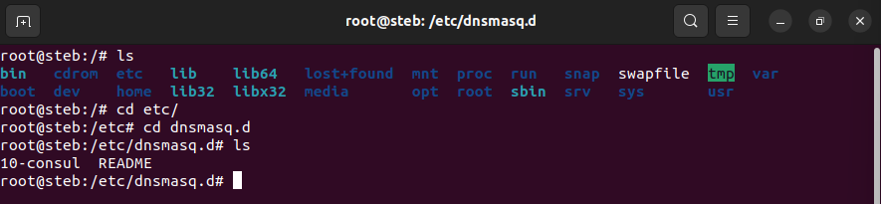

In this file write the following: server=/consul/127.0.0.1#8600

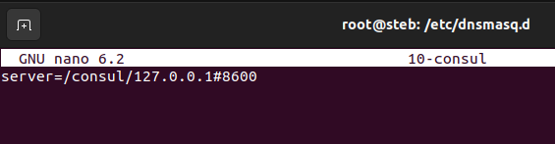

**Step 3:**

Go to the path: etc/ and change in this file: resolv.conf the following line, in this way: nameserver 127.0.0.1

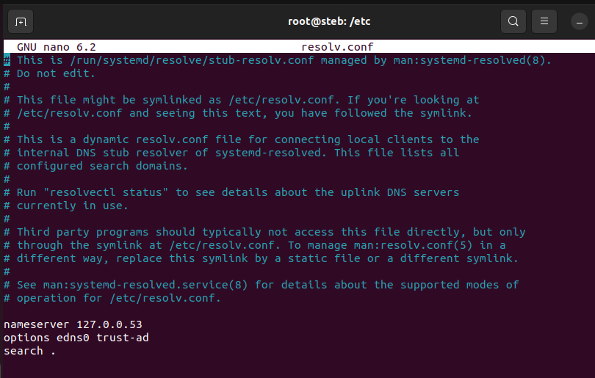

**Step 4:**

Now, start the containers of microservices starting with consul, postgres and data bases and finally the apps.

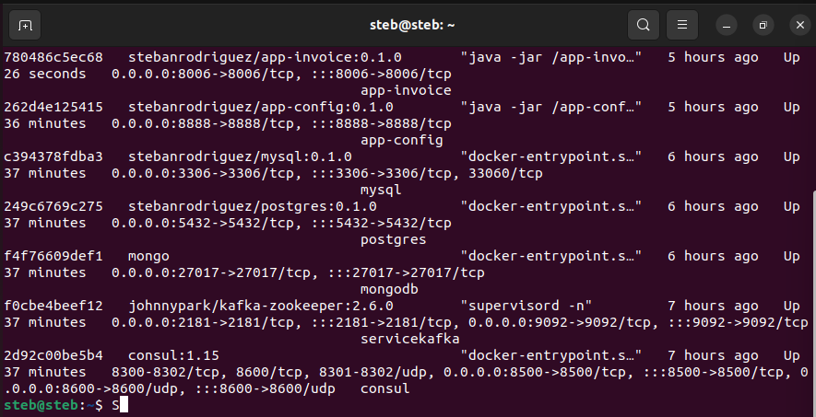

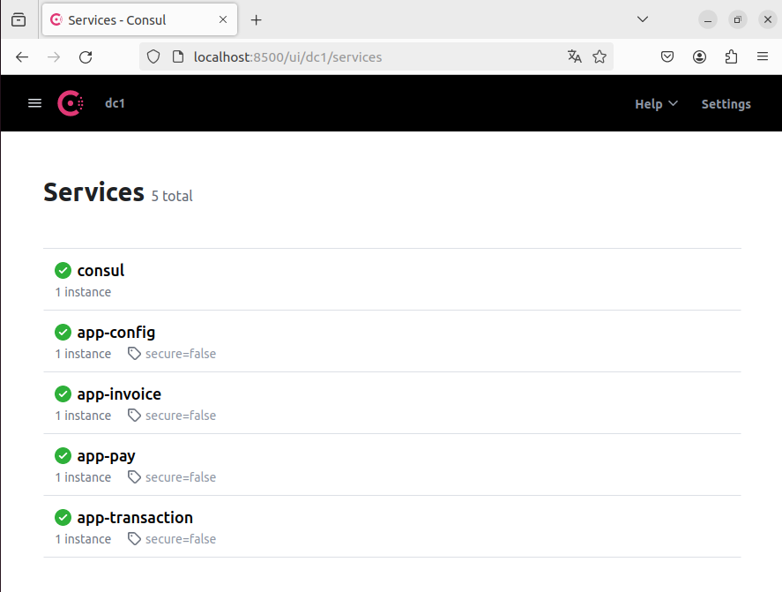

**Step 5:**

Now, put the command dig app-config.service.consul that allows you to obtain information on how domain names are translated into IP addresses and vice versa.

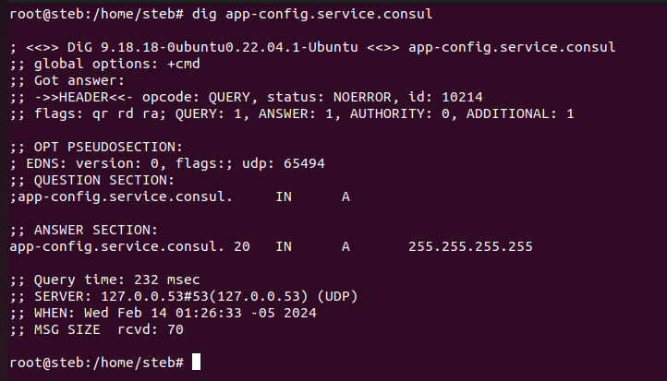

Now do it for other services:

Invoice service:

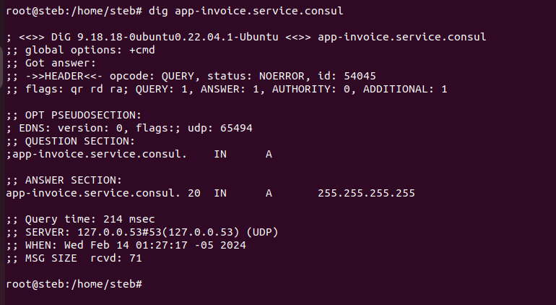

Pay service:

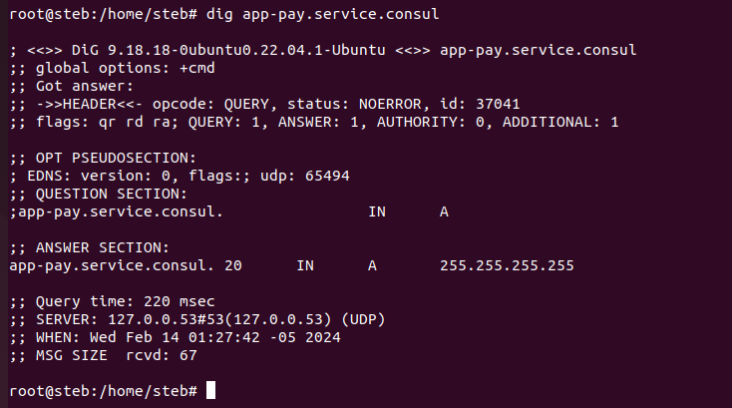

Transaction service:

